**14.3.1**

Are you hungry? There are breakfast

No. I’m not having breakfast

You are having breakfast today

Not today, not tomorrow. **I don’t eat breakfast in the morning**

You don’t eat breakfast?

No. **What do you do in the morning?**

**I get up at 6 AM** **and go to the gym**. I like running

When do you go to the gym?

Monday, Tuesday, Wednesday, Thursday and Friday, I go to the gym in the morning. **Then I take a shower**. **After that, I go to work.**

Wow. I don’t go to the gym.

What do you do in the morning?

**I wake up at 7 AM**. **Then I take a shower and I go to work**. **I eat breakfast every day**

**I eat lunch every after noon**

I know you eat lunch. You eat with me

That’s right. Do you want to go to the gym with me?

Every morning at 6 AM?

Yes

No, I have to sleep in the morning, **I sleep until 7 AM every morning**

That’s okay. Do you go out at night?

No, **I don’t go out at night**. I staying my apartment at night. Do you go out?

I don’t go out, I have work to do at night, every night

**I fall asleep on my work** /fɔːl/ /əˈsliːp/ buồn ngủ

**I fall asleep on my desk after lunch**

Here?

Yes. **After I eat, I go to my desk and then I sleep for thirty minutes**

I can’t sleep at work. I don’t want Todd see me sleeping

Why isn’t Aanya eating breakfast?

* She doesn’t eat in the morning

What does Aanya do in the morning?

* She goes to the gym.

Which is true?

* Aanya eats lunch with Khae.

Khae doesn’t want to the gym because she wants to sleep in the morning

What does Aanya do after lunch?

* She sleeps on her desk

I wake up at 6 AM every morning

I go to the gym after I wake up

I eat breakfast and then I take a shower

I go to work at 8 AM every day

I don’t eat lunch very day

Do you stay in your apartment at night?

Hi, I’m Martin. I am leaving for work now. I wake up at 8 A.M. every morning, and I listen to the radio. Then I take a shower and eat breakfast. After that, I go to work. I do my work until 1:00 P.M., and then I eat lunch with my friend. After lunch I go to the gym for one hour. I get home at 5:00 P.M. and watch TV.

What does Marting do every morning?

* He listens to the radio at 8 AM

Martin takes a shower after he listen to the radio

Martin stays at the gym for one hour

What does Martin do every evening?

* He watches TV

**CONVERSATION**

Do you like get up early?

Yes, I get up at 6:30 AM every morning

What do you do after get up?

First, I take a shower.

Do you eat breakfast in the morning?

No, I don’t eat breakfast, but I drink cup of coffee every morning.

What time do you go to work?

I go to work at 8:30

How do you get to work?

I take the bus

Do you eat lunch at work or Do you go out for lunch?

I have to do a lot of work so I eat food in my desk.

What do you do after work?

I go home and watch TV.

Do you cook dinner at home or Do you go to the restaurant?

I stay at home and I cook dinner.

I go to work every day at 9 AM.

I eat breakfast after I take a shower.

I drink two cups of coffee after breakfast

I eat lunch with my boss at 1:00 PM every afternoon.

My sister watches TV after she finishes work every night.

My brother doesn’t go to the gym on Saturday mornings.

Dan: Do you go to work by car?

🡪Mike: Yes, I do

What do you do after work?

🡪I go to the gym.

Are you cooking dinner?

🡪Yes, I am

What do you do before work?

🡪I take a shower.

**14.3.2**

I’m come in. What do you want?

We have a meeting right now.

We do. Yes. We do, sit down.

Why are we here?

**I want to list of your favorite colors.**

You want to list of favorite colors.

Yes. **Take a piece of paper**. **Give a pen**. **And write your favorite colors on it**. **Then you give me the paper.** **Then I give the list to the Big Boss**

Why?

Big boss wants to print a break room a new color

So you want to know a favorite color. That’s nice.

Yes.

I like pink.

**Don’t tell me what you like**. **Write it on the paper.**

Ok, I can write it on the paper.

Good, thank you.

Can you take it the Big boss now

I have work to do. Khae can give it to the Big boss. Do you know the Big boss in the office? **Go** **out my door and turn right.** Walk to the end of the hall. His office is there. **Give these papers to him**. Can you do that?

Yes. I can do that. Walk out of your office and turn right. It is he office the end of the hall

Good. Go now

The meeting is over

Yes. The meeting is over. Go to work. Close my door, please

Why do Khae, Aanya and Marco go to Todd’s office?

* They have a meeting

Todd needs to see his employees because he wants a list of their favorite color

What does Todd give Aanya, Khae and Marco?

* Pieces of paper

Whose favorite color is pink?

* Khae

Why does Khae have to take the list to The Big Boss?

* Todd needs to do work.

Get me some coffee.

* Sorry, we only have juice.

Can you take this to the Boss?

* Ok, Where’s her office?

Write down your favorite movie.

* I don’t have a pen.

Can you make me some food?

* What do you want to eat?

Don’t put the pens there.

* Where can I put them?

Can you call John, please?

* I don’t have his phone number.

Give a pen.

* Here you are.

And write your favorite colors on it.

* My favorite color is pink.

And then you give me the paper

* OK. I understand

What does Todd want?

* He wants someone to take the list to The Big Boss.

Where is The Big Boss office?

* At the end of the hall

**CONVERSATION**

Marco, come to my office now!

OK. What do you want?

I want you to take this list to the Big Boss. Do you know where his office?

No. I don’t.

Go out my office and turn right. It’s the end of the hall.

Ok, I turn right and I walk to the end of the hall.

Yes, the office has red door, it’s on the left.

OK. The office with the red door on the left.

Put the list on his desk and then you close the door. Do you understand?

Yes. I put the list on his desk.

And then?

I have to close the door

Good. Go now!

OK. See you later!

Where is the office?

* At the end of the hall, on the left

You have to write your favorite movie

What do you have to do?

* You have to give her the pen

Which is the correct order?

* Go into the room, sit down. Take out a piece of paper /piːs/

Which is true?

* Go to the end of the hall. Open the door

What do you have to do?

* Write two colors

Which is true?

* You don’t need to close the door

Which is NOT true?

* You don’t need to write your mother’s name

**14.3.3**

Excuse me! **What are you doing?**

**I’m giving these papers to The Big Boss**. **What’s he doing? Is he working?**

Yes, **He’s talking on the phone**. It’s an important phone call

**I’m waiting for him.**

You can wait here. You can give this paper. What are they?

These are the color for the break room.

**I’m going to his office now**. **I’m bringing him a cup of coffee**. Do you want to give me the paper?

OK. Thank you

What is it?

Look at this. Do you want to change something?

Yes. Can I have a paper? All I write something new

**Why are you laughing?** /læfing/

**I’m laughing, because Todd doesn’t like pink**

Why is Khae looking for the Big Boss?

* She needs to give some papers to him

Why is the woman going to the Big Boss’s office?

* To give him a cup of coffee

Khae gives the woman pieces of paper

What does Khae change on the paper?

* The colors

She is eating salad right now.

She is talking on the phone right now.

They play tennis every Sunday.

What are they doing?

* They are drinking coffee.

How do you go to work?

* I take the subway every day

Is your sister at home now?

* No, she is working at her office

I’m waiting for my friends.

What are you doing?

Ahmed is talking on the phone now.

I’m working on my laptop.

Are you listening to me?

The children play basketball every day

I'm laughing because the movie is funny.

**CONVERSATION**

I'm Gred, your's new employee. Nice to meet you

It's nice to meet you too. Let me show you the office. That is Nicole

What's she doing?

She's writing emails. And that's Oliver over there

What's he doing?

He's talking on the phone to a customer

What's this room?

This is a break room. That's Steve

What's he doing?

He's making coffee. He makes coffee for other employees every day

What do people do in the break room?

They take a break and eat lunch in here

Are people eating lunch, now?

No. Everyone is woking.

What are you doing?

--> I'm waiting for my friend

Do you go to work by bus?

--> No, I take the subway sometimes

Can you help me now?

--> Sorry, I can't because. I'm doing my work

Can you play tennis?

--> Yes, I can

What's the man doing?

--> He's reading a book

What do you want now?

--> I want a cup of tea

Why are you laughing?

--> I'm reading this book and it's very funny

What's your job?

--> I work for a big company

I'm bringing Mary a coffee. Do you want a cup too?

--> No, thanks

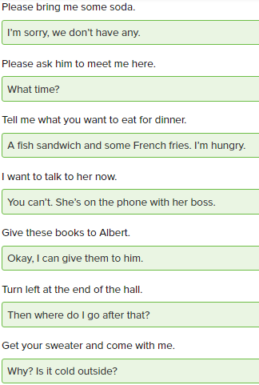

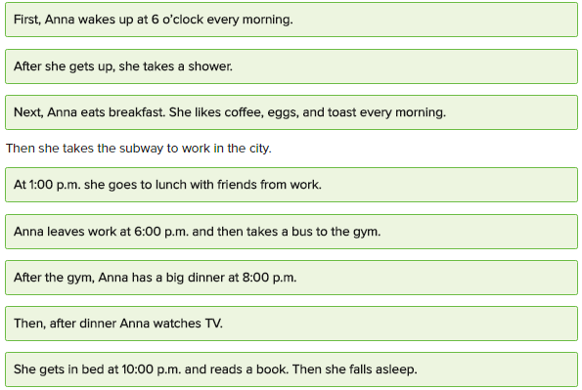

She's eating a big dinner with her roommate in their apartment

Tomen and Lily are working on their laptops

I go out somewhere every Saturday night

She buys all her clothes online

Steffan's buying a new red sweater for the party

Muriel's going to her gym class

Do you eat a big breakfast every morning?

He works at home in the evening

What does Mark do first when he wakes up?

* He takes a long shower at 6:00 AM

What does Mark do next?

* Mark take a bus to work in the city

What does Mark do before he gets to his office?

* He buys breakfast at the coffee shop

What does Mark do after he leaves work at 6:00 PM?

* He goes home and makes dinner

What is the last thing Mark does at night?

* Mark goes to bed and falls asleep

**1/8**

1 Patricia wakes up at 6 every morning.

2 Martin goes to the gym before breakfast.

3 Martha has breakfast every morning.

4 I take a shower. Then I leave for work.

5 They like running before work.

6 I fall asleep doing my work.

**2/8**

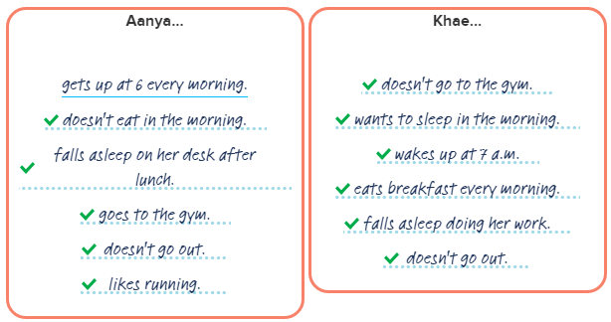

**3/8**

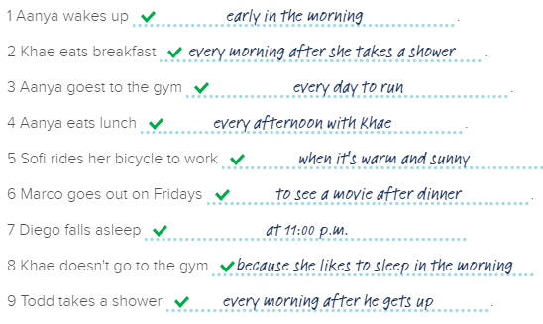

**4/8**

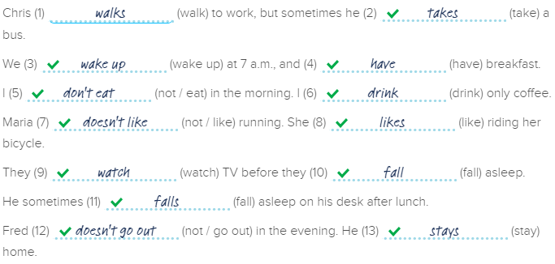

**5/8**

Todd: Marco, come to my office now.

Marco: What do you want?

Todd: Take this list to the Big Boss.

Marco: Okay. Where is his office?

Todd: Go out my office and turn right. It's at the end of the hall.

Marco: Okay. I turn right, and then I walk to the end of the hall.

Todd: Put the list on his desk. Close the door.

Marco: Okay. I close the door.

Todd: Good. Go now.

Marco: See you later.

**6/8**

1 The assistant is sitting at the desk.

2 Khae is waiting for the Big Boss

3 The assistant is bringing the Big Boss coffee /əˈsɪs.tənt/

4 Khae is laughing because Todd doesn't like pink

5 Todd is sleeping on his desk

6 They are talking in Todd's office

**7/8**

1 Where is Mr. Smith's office?

--> Turn right. His office is on the left at the end of the hall.

2 What is the Big Boss doing?

--> He's busy. He's talking on the phone.

3 What is the assistant doing?

--> She's bringing him a cup of coffee.

4 What do you have to do?

--> I have to take the pen and paper and write your favorite movie.

5 What is Nicole doing?

--> She's writing emails.

6 What is Oliver doing?

--> He's talking on the phone to a customer.

7 What is everyone doing?

--> Everyone is working now.

8 What do you have to do?

--> I have to walk to the end of the hall and open the door on the left.

**8/8**

I wake up at 6 a.m. every day. After I get up, I got to the gym. I like running. After the gym, I take a shower. I drink coffee after shower, but I don't eat breakfast. I go to work at 8:00. I eat lunch at noon with my friend. I leave work at 5:00. After I come home, I cook dinner. After dinner, I watch TV or read a book. I fall asleep at 11 p.m.

It's 8 p.m. now. I'm at home. I'm sitting and reading a book. My roommate is watching TV. She's watching a movie. We are drinking coffee.